Name: -------------------------------- Date: ------------------------

Year 11 Practice test on intermolecular forces and solutions

- Which of the following shows the correct shapes of molecules?

(a) | CO₂ | Trigonal planar
(b) | BF₃ | Linear
(c) | SO₂ | V-shaped
(d) | NH₃ | Tetrahedral

( 1 mark)

2.Compound X is a strong electrolyte, compound Y is a weak electrolyte and compound Z
is a non-electrolyte.

- Explain the differences between compounds X, Y and Z when dissolved in water in terms of their degree of ionisation and give an example of each type of substance. (6 marks)

________________________________________________________________________

_________________________________________________________________________

_________________________________________________________________________

Example of a compound like X _________________________

Example of a compound like Y _________________________

Example of a compound like Z _________________________

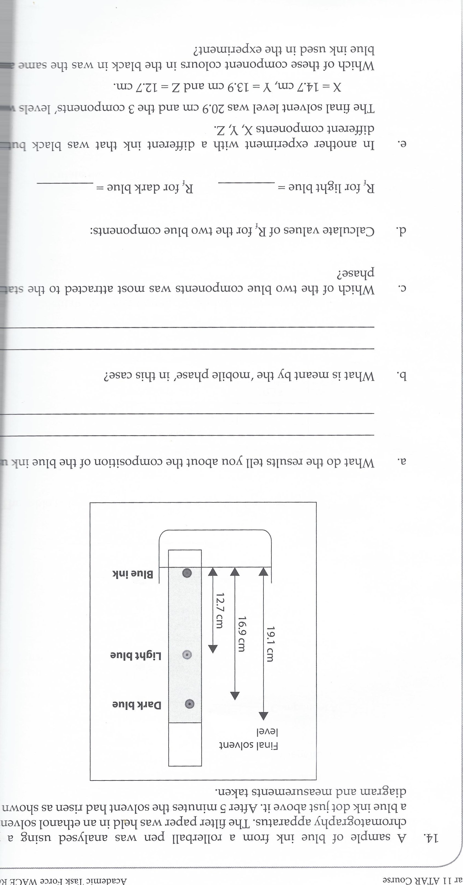

A sample of blue ink from a rollerball pen was analysed using a paper chromatography apparatus. The filter paper was held in an ethanol solvent with a blue ink dot just above it. After 5 minutes the solvent had risen as shown in the diagram and measurements taken.

(a) What do the results tell you about the composition of the blue ink used? (1 mark)

_________________________________________________________________________

_________________________________________________________________________

(b) What is meant by the ‘mobile phase’ in this case? (1 mark)

_________________________________________________________________________

_________________________________________________________________________

- Which of the two blue components was most attracted to the stationary phase?
(1 mark)
_________________________________________________________________________
(d) Calculate values of R_{f} for the two blue components:
be the greatest. (2 marks)

R_{f} for light blue = ____________________________________________________________

R_{f} for dark blue = _____________________________________________________________

(e) In another experiment with a different ink that was black but had 3 different components X, Y, Z.
The final solvent level was 20.9cm and the 3 components’ levels were:
X= 14.7cm, Y = 13.9cm and Z= 12.7cm.

Which of these component colours in the black ink was the same as in the blue ink used in the experiment? (4 marks)

_________________________________________________________________________

_________________________________________________________________________

_________________________________________________________________________

_________________________________________________________________________

_________________________________________________________________________

_________________________________________________________________________

Total = /16

